Technical Description
for the project on
Waste Collecting System

Trash Group
EGBs:
Monica Amovilli
Célia Lemen
Sonia Noguer
Clément Vissac
ICTs:
Nuno Hespanhol
Enrique Navarro
First approach

In our first meeting with the ICT supervisor, the main lines of the system were drawn. It is clear that there will be some sensors inside each container, but the mechanical part not being part of the project no more details were set.
Then, that independent set of sensors (from now on, simply "the box") will send a signal to reach the main data handling system. GSM was suggested due to its low cost and because its security methods make it the most secure cellular telecommunications standard currently available. But as this group has already a great delay, the idea of creating a simple but functional prototype seemed reasonable; and then, if there's time, add as many correction and amplifications as possible.
So the main ideas set in that meeting are that once the "container full" message comes to the server, this will record all the information, so when the collecting begins these data will be used to find the shortest path that visits all the full containers.
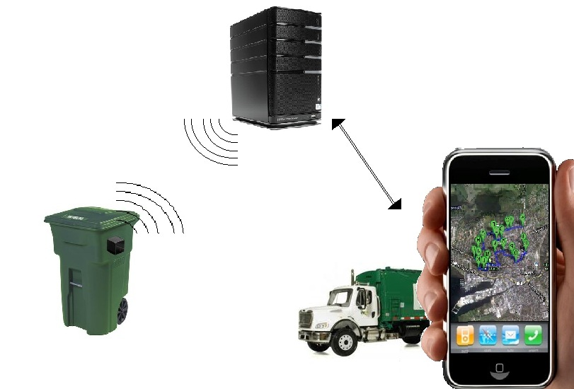

Prototype definition

Once the general system description established, some in depth choices have been made. On the side of the box communication we will just simulate it through a computer program which will send the signal simply through TCP/IP protocol (internet).

On the server side a mySQL database will be set up, and PHP scripting technology will be used at all points:
- Establishing TCP socket communication (using stream_socket_* functions).
- Providing security to avoid unwanted connections to the system using mcrypt library.
- Ensuring database stability and backup
- Creating under demand the best path for a given set of containers, using Dijkstra's shortest-path algorithm for arbitrary directed graphs (as there will be no negative vertices)

Finally, on the client side, an applet is to be made for a user-friendly way of showing the resulting path. We intend to profit Google Maps to show the route to follow and so profit from the advantages of this widely known interface.

Once this done, a working prototype can be tested and the basic objectives of this project will be filled.

Expanding the system

Many features could be added for a better approach of this system to a productive form.
Here's a list of some of them (only on the technical part) that this group will try if deadlines gives us the chance:
- Creating the box, with its low-level GSM programing and solving the power-supply problem.
- Setting some surveillance tools for the server side.
- As containers may change their position, a special applet can be created to register container id and new position. This could also be a new functionality on the client-side applet.
- Publishing the results of our work (specialized reviews, web site)

